1.1
The project is a web service designed to simplify and optimize the process of raising funds for specific goals across various sectors and causes.
1.2
A the current state we have Functional and Non-functional requirements, Concept of Operation, Requirement Analysis, Software Requirements Specifications and System Design
These deliverables collectively provide a clear roadmap and actionable insights, including system design, prototype development, and testing.
1.3
The primary goal of the project is to design, develop, and deliver a fully functional web service.
By balancing speed with quality, the project aims to deliver a web service that not only meets the objectives but also serves as a scalable and reliable solution for long-term use in the fundraising ecosystem.

2
The project involves a diverse range of stakeholders, each playing a unique role in the system's functionality, success, and impact. These stakeholders can be categorized based on their objectives, interactions with the platform, and contributions to its ecosystem.
  - Military
  - Health services
  - Animal shelters
  - Homeless shelters
  - Orphanages
  - Educational facilities in need
  - Retirement homes
  - Grants coordinators
  - Government
  - Customers who wish to donate
  - Banking services
  - Advertisers
The success of the platform depends on fostering collaboration and trust among these stakeholders. While donors provide the financial basis, organizations rely on the platform to enhance their message, and supporting entities like banks and advertisers ensure seamless operations. The platform acts as a bridge, creating a sustainable ecosystem where diverse interests come together for collective impact.

The relationships among these stakeholders are interconnected and symbiotic, creating a dynamic ecosystem where each group relies on and benefits from the others. Here's a brief overview of their relationships

3.1
The project follows the Agile methodology, using the Kanban framework from the start. The Kanban board has been an ideal tool, offering flexibility and optimizing workflows.
Kanban reduces pressure on employees by eliminating frequent meetings and allows to track progress through Kanban boards. This saves time and makes the development process easier to manage without using complex units like epics or story points.
3.2
Key Roles and Responsibilities
- Product Owner: Ensures the product meets stakeholder expectations by understanding their needs and coordinating with departments.
- Sales Representative: Assists customers, facilitates deals, and maintains satisfaction for both the company and clients.
- Software Engineers: Responsible for software development.
- UI/UX Engineers: Design intuitive and user-friendly interfaces.
- QA Department: Tests and identifies bugs, ensuring the product's quality in collaboration with engineers.
- Server Department: Maintains and secures company servers and systems, addressing technical issues.

4.1
To gather functional and non-functional requirements, a structured process is essential to ensure completeness, accuracy, and alignment with the stakeholders' needs. Functional requirements focus on what the system should do to meet user expectations, while non-functional requirements define the quality and usability aspects, shaping the overall user experience.
For the donation platform, the functional requirements specify core actions. These include an instant donation button beneath each donation case, which redirects users to a payment page. Before proceeding, users are required to complete a CAPTCHA verification to confirm they are not bots. Once on the payment page, interactive payment options allow users to choose their preferred method, such as bank transfer, Google Pay, Apple Pay, or PayPal. Additionally, a loading bar will display progress on each donation case, giving users a sense of achievement as donations accumulate.

The non-functional requirements guide the platform's aesthetic, security, and accessibility standards. The main design uses a clean, minimalistic look with Montserrat font and a white-and-blue color scheme. The donation page design includes detailed descriptions of each donation case, such as the organization name, which adds transparency for donors. For financing, each case uses a unique financial address for tracking purposes. Security considerations ensure donations are open to users from all countries, while protecting sensitive data.
In summary, these requirements collectively address the platform’s operational and experience-driven needs, ensuring it is functional, secure, and user-friendly for a broad audience.

4.2
To create an effective donation platform, it’s essential to define requirements clearly to make the site both user-friendly and secure.
(optional)
External Interfaces include:
User Interface – the site should be simple and intuitive, allowing users to easily make donations, track their contributions, and view details about each cause.
Hardware Interface – the site should work smoothly on various devices, like PCs, tablets, and smartphones.
Software Interface – secure integration with third-party payment systems (such as PayPal) for reliable donation processing.
Communication Interface – use of HTTPS protocols to protect users' data.

Functional Requirements specify what the site should do:
Users can select the donation purpose, enter an amount, and choose from multiple payment methods, making the donation process quick and straightforward.

Non-Functional Requirements cover quality aspects:
Performance – the site should load quickly, handle high traffic, and ensure payment processing is smooth.
Security – regular security audits and updates to protect user data.
Scalability – support for increasing numbers of users and donations as the platform grows.
Usability and Accessibility – designed to be easy to use and to meet accessibility standards (such as WCAG), ensuring that all users, including those with disabilities, can navigate the platform.

In summary, these requirements aim to make the platform reliable, easy to use, and safe, creating a positive experience for all donors.
In summary, these requirements ensure the platform’s functionality, security, and ease of use, creating a positive and trustworthy experience for donors.
4.3
In the Requirements Analysis step the goal is to ensure that the requirements gathered are well-organized, feasible, and aligned with project objectives.
First of all we categorize by the functionality and separate in logical groups. Collect Technical Requirements, User Requirements: Specify what the user expects from the system, often including user stories or use cases.
Next step is to Rank requirements based on their importance and urgency. This helps ensure that critical features are addressed first and helps allocate resources effectively. As a potential obstacles Stakeholders may have conflicting priorities, which can make it difficult to reach a consensus on what’s most important.

Inputs to Requirement Analysis
Inputs are documents or information sources that feed into the requirement analysis process. They provide the baseline knowledge, context, and direction required to identify and define project requirements.
And defined means Outlines the purpose, objectives, and scope of the project, are there Any documentation about the current system, product, or process that the project aims to replace or improve.
Documentations such as Charts, Templates and Samples
Outputs from Requirement Analysis
Outputs are the final deliverables or documentation resulting from the requirement analysis, outlining what the system or project must accomplish. These outputs ensure everyone involved has a clear understanding of the requirements and a reference point for later stages of development.
Analyze Feasibility: Check each requirement for technical, financial, and operational feasibility. Eliminate or modify requirements that are impractical or overly costly.
Analyze and Prioritize Requirements
Were we Ranked requirements based on their importance and urgency. This helps ensure that critical features are addressed first and helps allocate resources effectively.

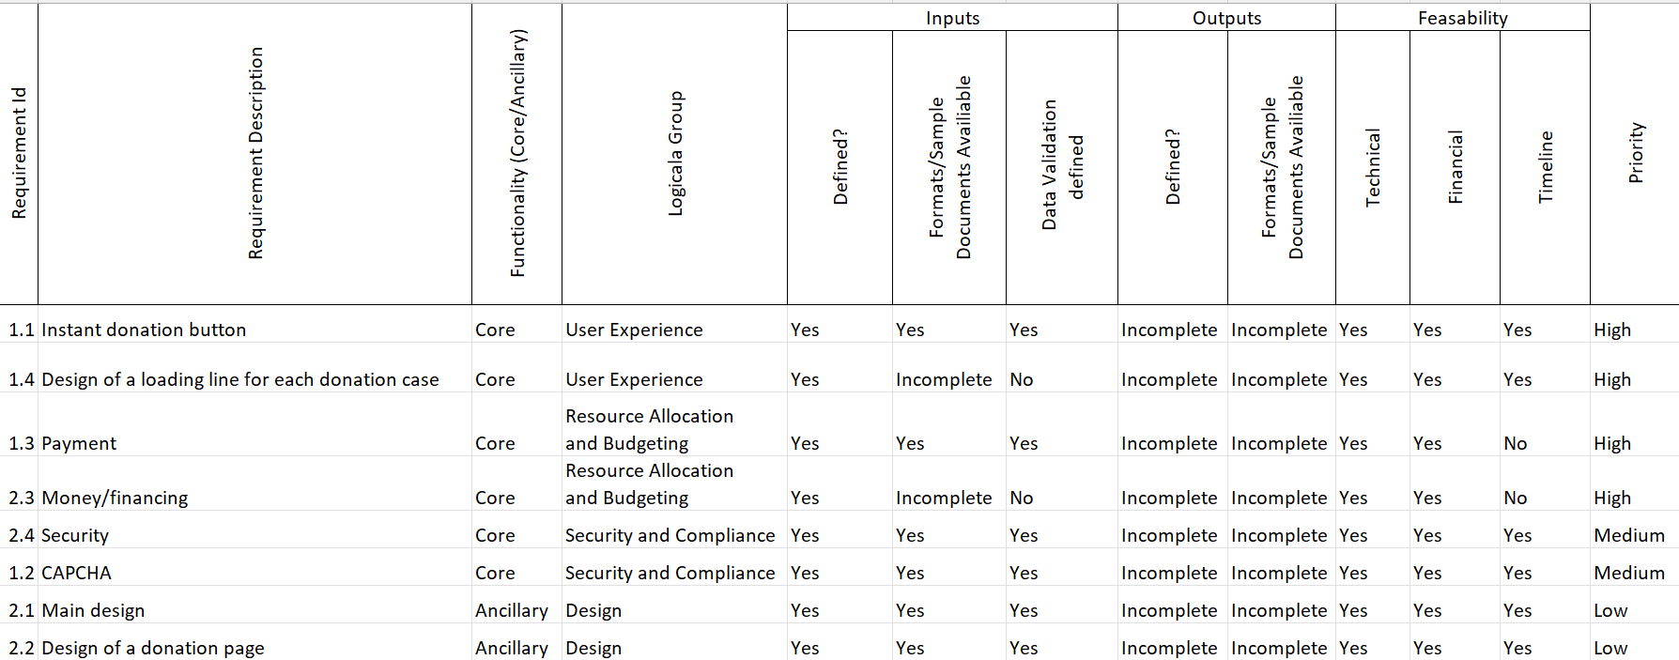
4.4
• Stakeholder Meetings: Discuss and align requirements with clients, managers, developers, and end-users.
• Requirement Validation: Ensure requirements are clear, feasible, and within scope, encouraging feedback for clarity.
• Feedback & Adjustments: Document and address feedback, refining requirements as needed.
• Formal Approval: Finalize the document and obtain stakeholder sign-off to confirm agreement and prevent disputes.

5.1
The donation web service will use a microservices-based architecture with a client-server model for interaction.
We use microservices because of:
Scalability: Independent scaling of services based on load (e.g., Campaign Service can scale during high traffic).
Fault Isolation: A failure of one service (e.g., Notification) won’t affect others.
Flexibility: Services can be built using different technologies.
(show picture and not the text)
Front End
Web Client:
- Browsers interact with the service through a responsive web application;
- Allows users to browse donation campaigns, make donations, and manage their profiles.
Mobile Client:
- Native or hybrid mobile app;
- Supports push notifications and offline interaction for donations.

API Gateway
Acts as the single entry point for all client requests.
Functions:
- Routes requests to appropriate backend services.
- Provides rate-limiting, request validation, and authentication token checks.

Backend Services
- User Service:
Handles user registration, login, authentication, and profile management. Stores user details and manages roles (donor, campaign creator, admin).
- Campaign Service:
Manages CRUD operations for donation campaigns (creation, updates, visibility). Stores campaign metadata and references to associated media files.
- Donation Service:
Handles payment processing through third-party gateways. Maintains a ledger of donations and generates receipts. Supports one-time and recurring donations.
- Notification Service:
Manages real-time and scheduled notifications (email, SMS, push). Implements asynchronous processing using a message queue.
- Admin Service:
Offers tools for administrators to manage users, campaigns, and transactions. Provides reporting and analytics dashboards.
- Media Service:
Handles file uploads and retrieval for campaign images, videos, and documents. Integrates with cloud storage solutions like AWS S3 or Google Cloud Storage.
- Analytics Service:
Aggregates data from other services for real-time and historical analysis. Provides dashboards for campaign success tracking and user engagement metrics.

5.2
Client ↔ API Gateway. The client sends HTTP/HTTPS requests to the API Gateway.
API Gateway ↔ Backend Services. Backend services interact with the API Gateway through REST or GraphQL APIs.
Backend Services ↔ Payment Gateway. The Donation Service interacts with external payment gateways for secure transactions.

5.3
Relational Database (RDBMS):
PostgreSQL or MySQL for structured data like users, campaigns, donations, and transactions.
Cloud Storage:
Services like AWS S3 for storing campaign images, videos, and documents.

Using relational database for Users Table, Donation Campaigns Table and Donation Table, and for Media Metadata Table and Notifications Table using cloud storage.

5.4
Processes:
  - User interacts with the system (create/view campaigns, donate).
  - Payment gateway processes payments.
  - Notification system sends updates.
5.5
Security Test Scenarios
- SQL Injection. Validator will prevent the injection.
- Payment Rejection – in case of rejected bank transfer the website will not proceed further as there is two factor payment gateway.
Functional Test Scenarios
- User Registration. In case of duplicated email/weak password the registration would be reverted because of User Service.
Performance Test Scenarios
- High Traffic on the webservice. AWS cloud services will handle occurred issues.
Usability Test Scenarios
- Cross Platform Compatibility. UI is responsive and functions correctly and the webservice is provided for web and mobile interfaces.
- Accessibility Testing. Webservice is created by WCAG guidelines, so accessibility issues are minimized.

